Front End Technologies Week 2 Coding Assignment

**Points possible:** 70

|  |  |  |
| --- | --- | --- |
| Category | Criteria | % of Grade |
| Functionality | Does the code work? | 25 |
| Organization | Is the code clean and organized? Proper use of white space, syntax, and consistency are utilized. Names and comments are concise and clear. | 25 |
| Creativity | Student solved the problems presented in the assignment using creativity and out of the box thinking. | 25 |
| Completeness | All requirements of the assignment are complete. | 25 |

**Instructions:** In VS Code, or an IDE of your choice, write the code that accomplishes the objectives listed below. Ensure that the code compiles and runs as directed. Take screenshots of the code and of the running program (make sure to get screenshots of all required functionality) and paste them in this document where instructed below. Create a new repository on GitHub for this week’s assignments and push this document, with your JavaScript project code, to the repository. Add the URL for this week’s repository to this document where instructed and submit this document to your instructor when complete.

**Coding Steps:**

1. Style the website you made last week using CSS. Below are the requirements:
   1. Use only external CSS file (no internal or inline styling)
   2. Every element must be styled
   3. Create style rules using class, id, and element selectors

**Screenshots of Code:**

***HTML Screens:***

<!DOCTYPE html>

<html lang="en">

<head>

    <meta charset="UTF-8">

    <meta http-equiv="X-UA-Compatible" content="IE=edge">

    <meta name="viewport" content="width=device-width, initial-scale=1.0">

    <title>Document</title>

    <link rel="stylesheet" href="styles.css">

</head>

<body>

    <h1 id="headerStyle">About Us</h1>

    <div>

      <a href="home.html" class="newanchor">Home</a><br>

      <a href="about.html" class="newanchor">About Us</a><br>

      <a href="contact.html" class="newanchor">Contact Us</a>

    </div>

    <p>We are an example website solely dedicated to learning the basics of HTML and showing proper appreciation to thiccened beasts such as the one below</p><br>

    <img height ="300px" src="https://cdn.vox-cdn.com/thumbor/8o6MWZkevoUdQt2hmzyQbtga2C8=/0x78:1200x678/fit-in/1200x600/cdn.vox-cdn.com/uploads/chorus_asset/file/10725533/absolute_unit_sheep.jpg" alt = "Photo of early 1900s Absolute Unit">

    <h3>About Our Thiccened Beasts</h3>

    <p><b>"Thiccened Beasts"</b> is our jargon for describing animals that while although may have extra body weight, are also undeniably cute in appearance! Lorem ipsum dolor sit amet consectetur adipisicing elit. Soluta totam necessitatibus nemo, praesentium dignissimos, obcaecati quas quae, in exercitationem reiciendis alias eum sit eius! Similique cum optio necessitatibus molestias obcaecati. </p>

    <p>Lorem ipsum dolor sit, amet consectetur adipisicing elit. Quo sapiente dignissimos possimus, quas dolores nemo quibusdam natus blanditiis odit nobis, ipsa ea eos officiis nostrum corrupti voluptatum dolorem voluptatibus quia!</p>

</body>

</html>

<!DOCTYPE html>

<html lang="en">

<head>

    <meta charset="UTF-8">

    <meta http-equiv="X-UA-Compatible" content="IE=edge">

    <meta name="viewport" content="width=device-width, initial-scale=1.0">

    <title>Document</title>

    <link rel="stylesheet" href="styles.css">

</head>

<body>

<h1 id="headerStyle">Home</h1>

<div>

  <a href="home.html" class="newanchor">Home</a><br>

  <a href="about.html" class="newanchor">About Us</a><br>

  <a href="contact.html" class="newanchor">Contact Us</a>

</div>

<img src="https://files.worldwildlife.org/wwfcmsprod/images/HERO_harbor_seal_on_ice/hero_small/41yzw17euy_Harbor_Seal_on_Ice_close_0357_6_11_07.jpg" alt = "Photo of seal looking at camera">

<p>The<span> <a href="https://files.worldwildlife.org/wwfcmsprod/images/HERO_harbor_seal_on_ice/hero_small/41yzw17euy_Harbor_Seal_on_Ice_close_0357_6_11_07.jpg">photo</a></span> above is a picture of a thickened seal. </p>

</body>

</html>

<!DOCTYPE html>

<html lang="en">

<head>

    <meta charset="UTF-8">

    <meta http-equiv="X-UA-Compatible" content="IE=edge">

    <meta name="viewport" content="width=device-width, initial-scale=1.0">

    <title>Document</title>

    <link rel="stylesheet" href="styles.css">

</head>

<body>

    <h1 id="headerStyle">Contact Us</h1>

    <div>

        <a href="home.html" class="newanchor">Home</a><br>

        <a href="about.html" class="newanchor">About Us</a><br>

        <a href="contact.html" class="newanchor">Contact Us</a>

      </div>

    <table id="borderSeparate">

        <tr>

            <th>Site</th>

            <th>Link</th>

        </tr>

        <tr>

            <td>Facebook</td>

            <td><a href="#">Visit Our Facebook Page!</a></td>

        </tr>

        <tr>

            <td>Instagram</td>

            <td><a href="#">Visit Our Instagram Page!</a></td>

        </tr>

    </table>

    <form>

        <h2>Contact Us</h2>

        <input type="text" name = "firstName" placeholder="First Name">

        <input type="text" name = "lastName" placeholder="Last Name">

        <input type="text" name = "phone" placeholder="Phone Number (000)000-0000">

        <input type="submit" value="Submit">

    </form>

</body>

</html>

***CSS Screens:***

#headerStyle{

    background-color: honeydew;

}

div{

    width: 100px;

    height: 100px;

}

table, td, th{

    border: 1px solid black;

}

#borderSeparate{

    border-collapse: separate;

}

.newanchor:link{

    color:pink;

}

.newanchor:visited{color:greenyellow;}

.newanchor:hover{

    color: wheat;

}

body{

    background-color: cornflowerblue;

}

**Screenshots of Running Application:**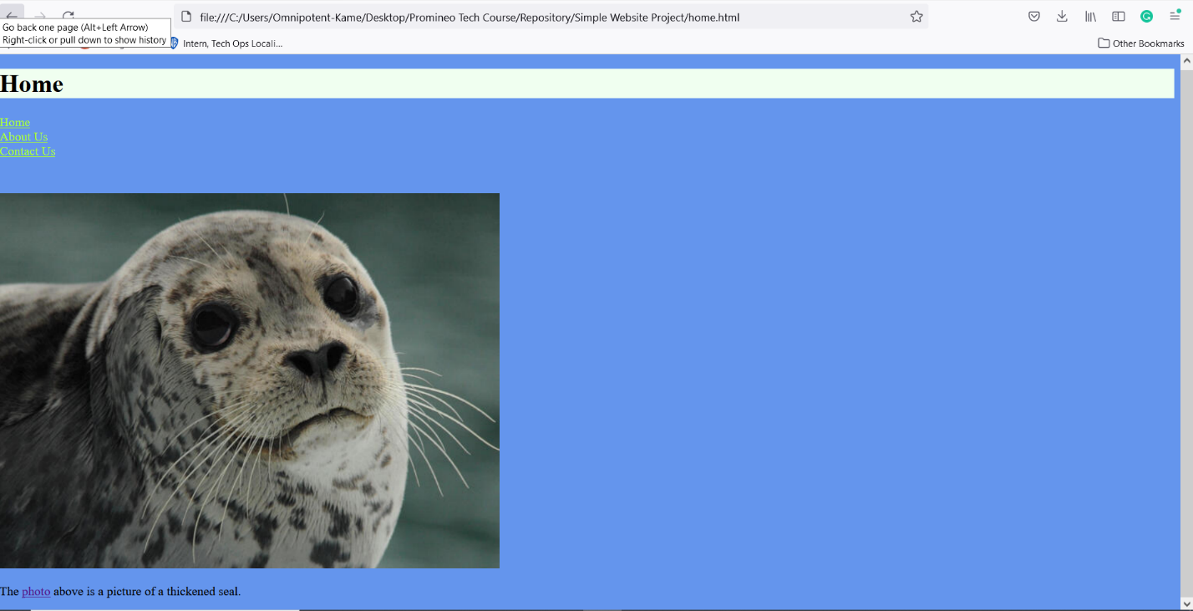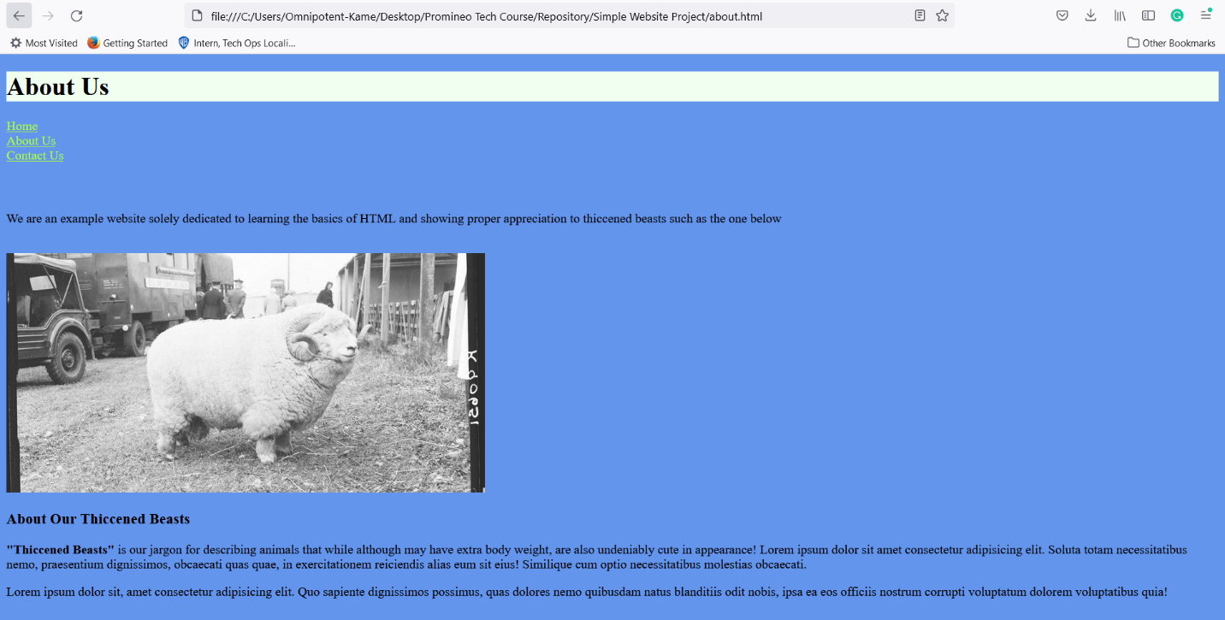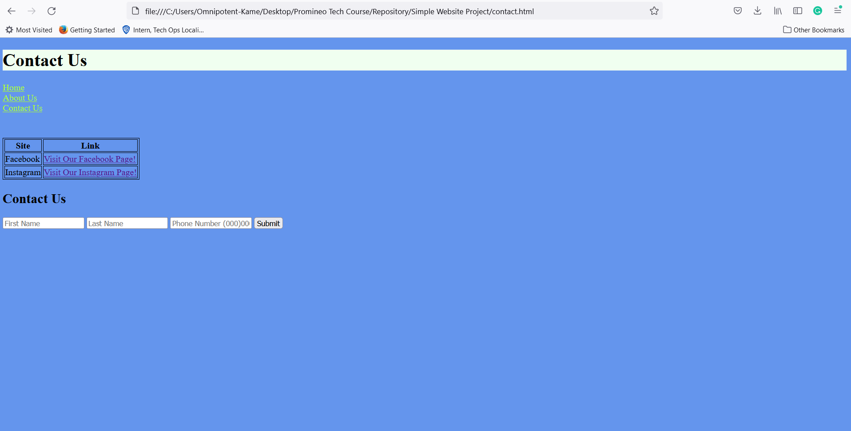

**URL to GitHub Repository:**

**https://github.com/Omnipotent-Turtle/Promineo.git**